ARM

# Objective:

The Smith & Nephew’s ARM developed using VBA customizations need to be converted to .NET framework in compatible with AutoCAD 2018, adhering to best practices, supporting 64 bit architectures.

# Overview:

This document gives an outline of input details need to generate required output, working flow and output details of ARM module in Smith & Nephew project.

# Description:

# Scope:

* ARM module is used to draw Left and Right Arm in the standard template drawing “SN.dwt” using the details from “MAINPATIENTDETAILS” block reference.
* For ARM module, first we need to update the attributes of “MAINPATIENTDETAILS” block reference using NEWPATIENT command. Without that, we can’t run ARM module.

# Technology:

We are using VB.net technology and AutoCAD 2018 for ARM.

# Deliverable:

AutoCAD 2018 customized plug-in DLL.

# Steps to Run:

1. Open AutoCAD 2018 and open a drawing using “SN.dwt” template file.
2. Run NETLOAD command in Command prompt.
3. Load the updated “SmithNephew.dll” file in AutoCAD.
4. Run NEWPATIENT command in Command Prompt and update the attribute values in “MAINPATIENTDETAILS” block reference.
5. Run ARM command in Command Prompt.
6. “Arm” dialog will be opened.
7. In that dialog, Enter the required details for Left or Right Arm.
8. After entering details, click calculate button for calculating corresponding MMs, Grams and Reduction values.
9. Click draw button
10. Now, the corresponding Left or Right Arm will be drawn successfully.

# Dialog Design:

# Left ARM:

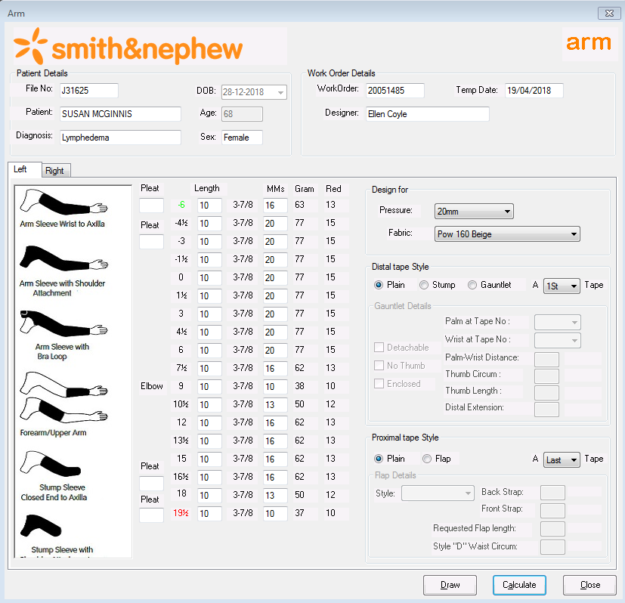

# Right ARM:

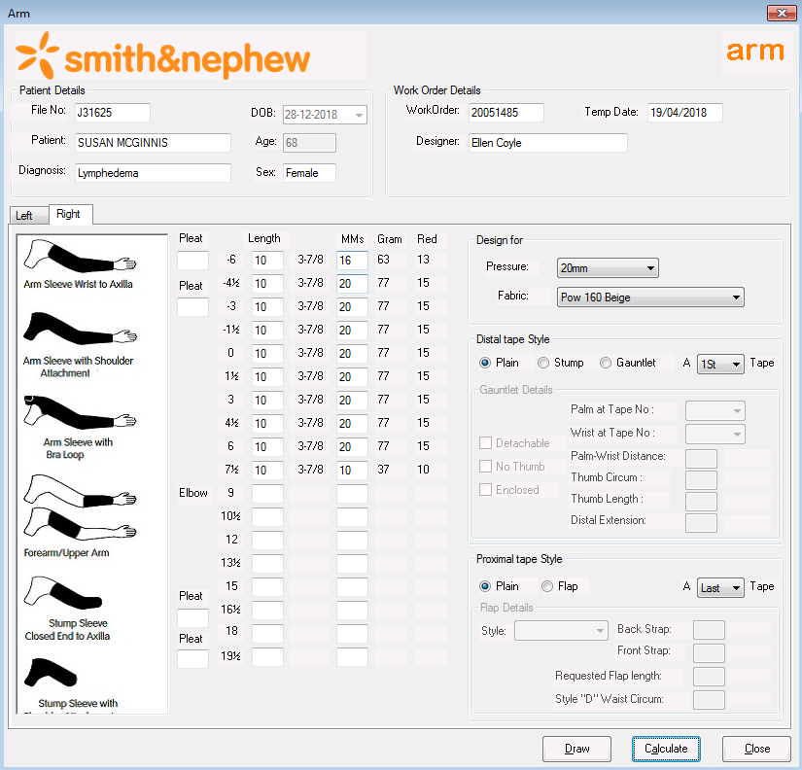

# Required Output:

# Left ARM:

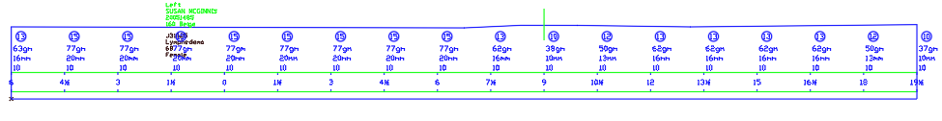

# Right ARM:

